YEAR 10 SCIENCE
DATA SHEET (EXAMINATION)

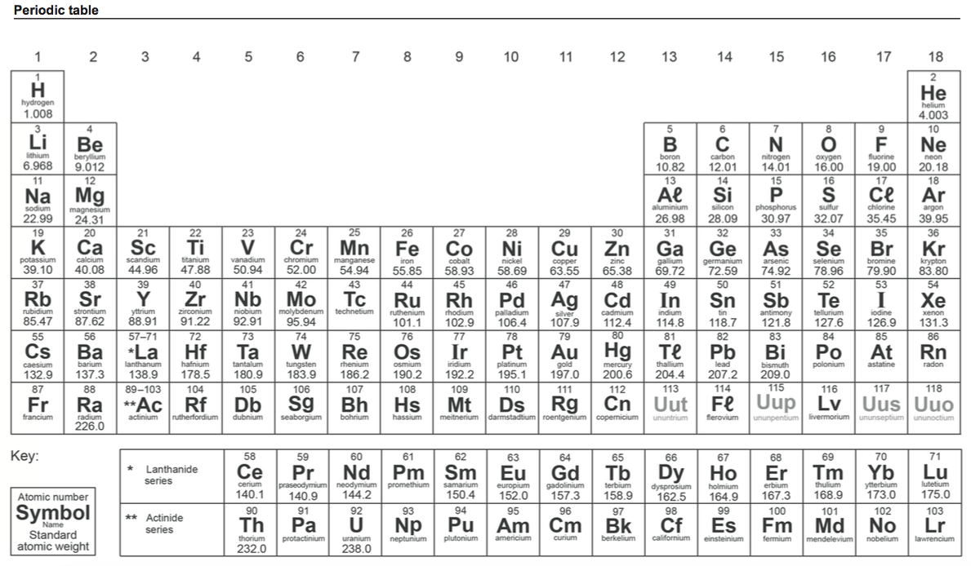

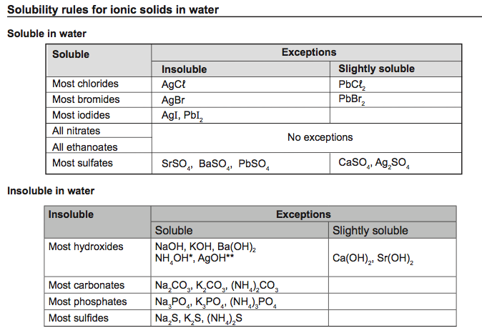

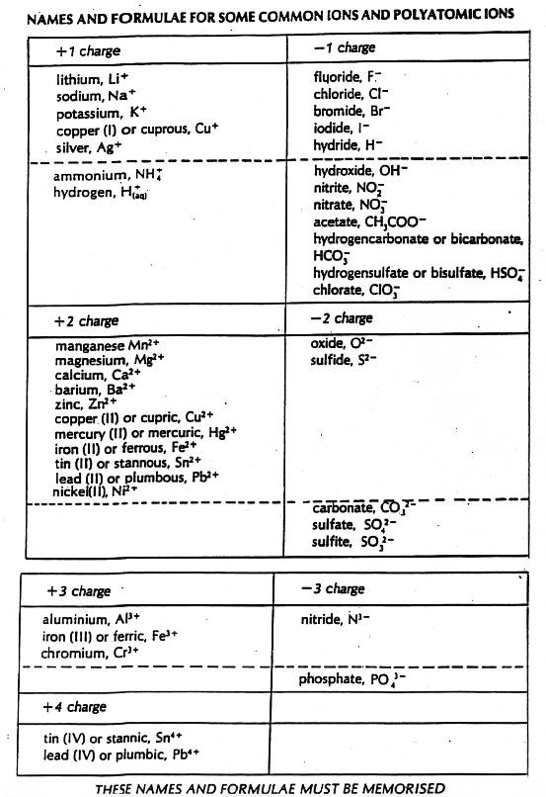

sp
d
t

Speed

v
s
t

Velocity

Acceleration v = u + at

m
F
a
Force F = ma

Weight F_{w} = mg
m
F_{w}ww
g

Acceleration due to gravity g = 9.80 m/s²

Converting km/h to m/s Divide the speed in km/h by 3.6 to get the speed in m/s.

